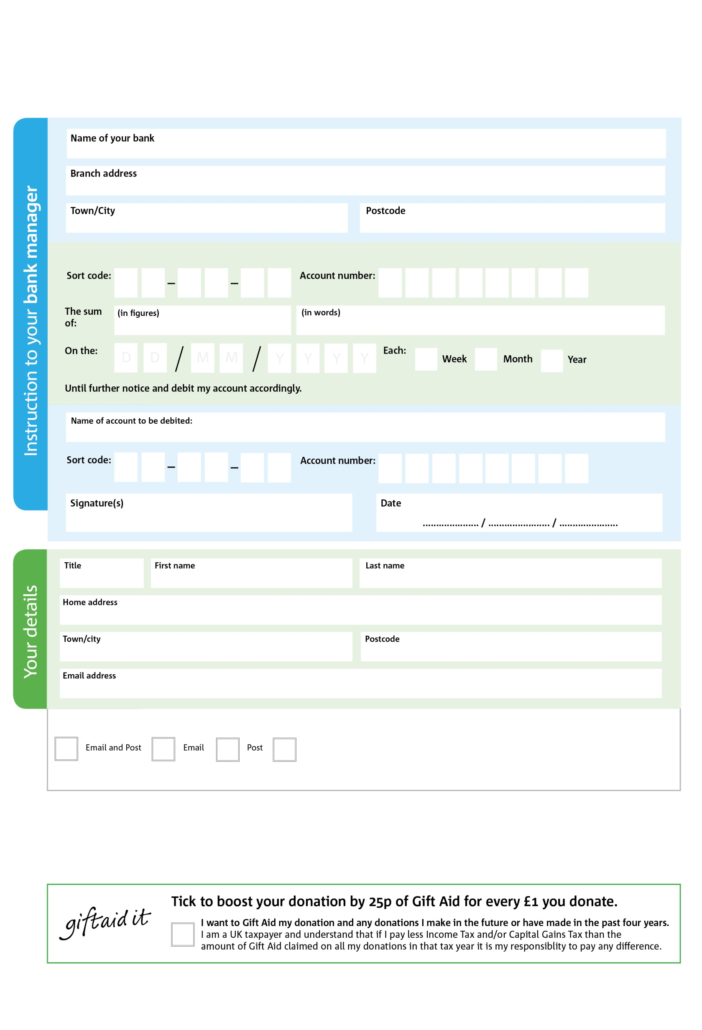

POSTAL ADDRESS: Aylesbury Foodbank, 44 Rabans Close, Rabans Lane Industrial Estate, Aylesbury, HP19 8RS

Reg. Charity No: 1179692 | Reg. in England & Wales

3

V

5X55

V

2X

V

6X

V

4X

V

8

V

3X3

V

9

V

**Please pass this form onto the foodbank, using the foodbank’s address at the bottom, who will save a copy for their records.   
They will then send it onto your named bank or building society.**

4X4

8X

3X33

0X

0X

2X

We would love to keep you up to date with information about Aylesbury Foodbank. Please tick your preference:

You can change your preferences any time by contacting us on 01296 395514 or emailing us at info@aylesbury.foodbank.org.uk.

I do not wish to receive future communications from Aylesbry Foodbank

Please pay Aylesbury Foodbank,

**Data protection**

*Aylesbury Foodbank is committed to protecting your privacy and will process your personal data in accordance with current Data Protection legislation.Aylesbury Foodbank collects information to keep in touch with you and supply you with information relating to our work. To unsubscribe from our newsletter, send a message to the email address above with the word unsubscribe in the subject line. A full data privacy statement for financial donors is available from the foodbank on request.’*

**Standing Order Mandate**

**aylesbury.foodbank.org.uk**

You can change your preferences any time by contacting us on XXXXXXXXXXX or emailing us at XXXX@XXXXXXXXXX.foodbank.org.uk

I do not wish to receive future communications from XXXXXX Foodbank